Project 1: Data Ingestion and analysis

* **Process:** From the previous project, I understood how to create a function to pull API data using the requests package, and how to parse JSON data into text. From there, I was able to look up how to create a MongoDB database and collection through pymongo, and insert the collected data into the collection. From there, I used the schedule documentation to schedule the function I created to run every minute at XX:00:00 for one hour. Creating the while loop to stop the schedule running after one hour was the trickiest part--annoyingly, I had the right method down to not use time.sleep in the beginning, but a small error prevented it from working and caused me to try other incorrect methods that caused drifting and take up more time. In the end, I was able to tweak my original however and figure it out.
* **Analysis:** For the factor, for every minute that the time is on it cubes that number. So for 12:10, the factor is 1000 $(10^{3}$). For the pi, the value starts at 4 on the hour and converges towards the true value of pi as the hour passes. For time, it is in GMT.
* 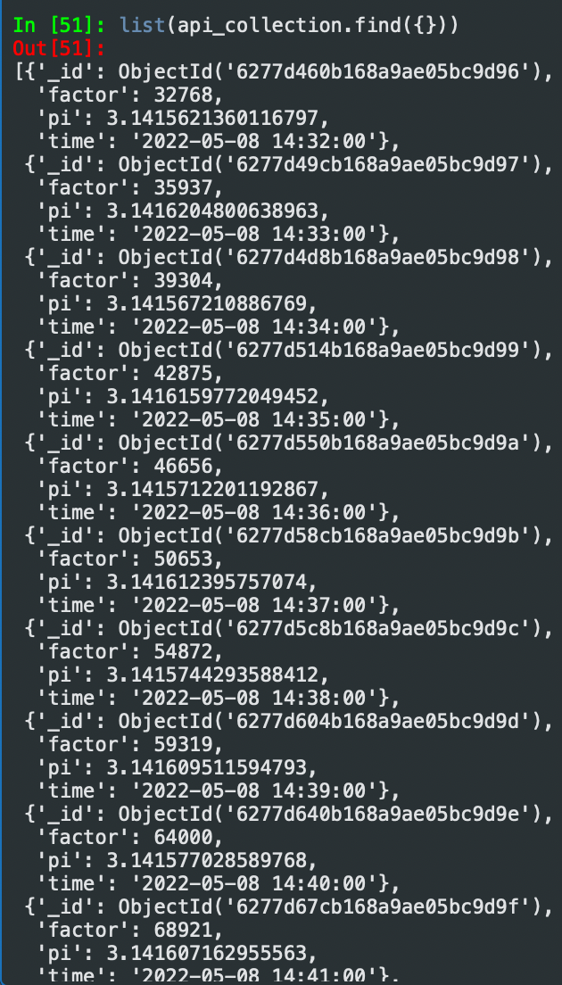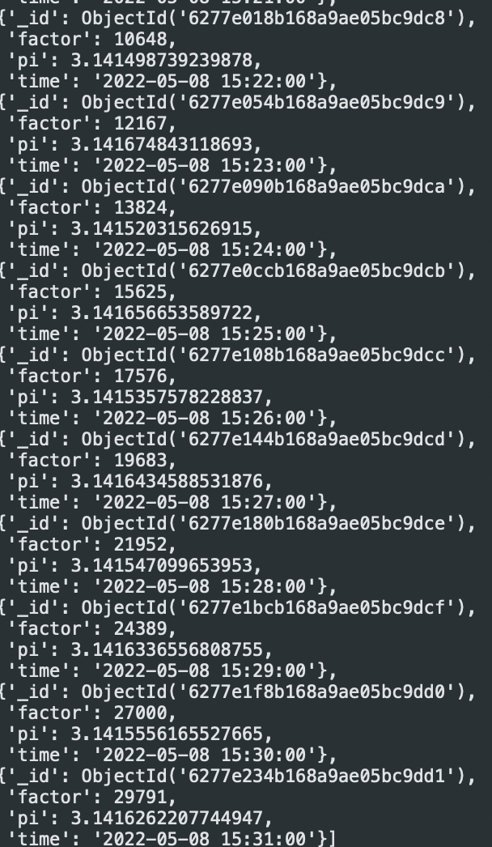

Project 2: Discord Bot

* Replit link: <https://replit.com/join/qifvxnulfy-spt2nvh>
* Discord server invite link: <https://discord.gg/PstF8Kde>